PENETRATING PANCREATICO-DUODENAL INJURIES: A 2-YEAR EXPERIENCE AT CMH PESHAWAR
Riaz Anwar Bashir, Shahzad Ahmed Qasmi*, Faran Kiani**, Mohammad Yasin*, Ahmed Waqas***
Combined Military Hospital Rawalpindi, *Combined Military Hospital Bahawalpur, **Combined Military Hospital Gilgit, ***Heavy Industries Hospital Taxilla
ABSTRACT
Original Article
Objective: To outline the various treatment options and outcomes in penetrating pancreatico-duodenal injuries with emphasis on the operative decision making strategies.
Study Design: Descriptive study.
Place and Duration of Study: Department of Surgery at Combined Military Hospital Peshawar, from 1st June 2008 to 30th May 2010.
Patients and Methods: All combat casualties with penetrating pancreaticoduodenal injuries (PPDI) received in ‘Emergency reception’ of Combined Military Hospital, Peshawar were included. Data was taken from the patients’ medical charts and by personal evaluation and entered in a proforma. The variables used were age, sex, cause of the injury, haemo-dynamic status, conscious level, intensive care treatment duration, time to initial exploration, associated injury, grade of pancreatic injury according to Penetrating Abdominal Trauma Index (PATI) scoring system, grade of duodenal injury (according to PATI scoring system), total PATI score, operative repair, total hospital stay, morbidity, and mortality.
Results: Twenty three patients having either or both of PPDI were included in the study out of 196 combat casualities. No case was excluded on basis of presence of associated injury. Mean age was 29.26 years (SD±6.489) with only one (4.3%) case of female gender, the rest were male patients or soldiers. Nineteen (82.6%) cases had primary mechanism/cause of injury being splinters from Improvised Explosive Devices (IEDs) or bomb blasts; while 4 (17.4%) cases had Gunshot Wounds. Eighteen (78.3%) patients were haemo-dynamically stable on arrival while 5 (21.7%) patients were unstable. Mean duration of stay in hospital was 10.6 days, with a range of 1-19 days (cases with high PATI score and un-stable haemodynamic status died with-in 24 hrs). Most cases of pancreatico-duodenal injury were of mild severity i.e. grade-1 or 2 and we encountered no case of grade-5 PPDI. Most commonly occurring associated injury was to small gut. Overall mortality was 6 (26.1%) out of 23 patients. "Pancreatico-duodenal mortality," or deaths attributable directly to duodenal or pancreatic injury or its management, occurred in only 1 patient. Other 5 died mainly due to associated injuries especially major vascular injury or head injury or due to increased contamination time in settings of colon or small gut injury.
Conclusion: The majority of pancreatico-duodenal injuries can be managed by simple repair and efficient drainage along with consideration of damage control principles of surgery in haemodynamically-compromised patients.
Keywords: Damage control surgery, Pancreaticoduodenal injuries, PATI score.

INTRODUCTION
Pancreatico-duodenal injuries are relatively rare injuries. These present a number of dilemmas in their management. The pancreas is injured in 3% to 12% of intra-abdominal trauma cases¹. The duodenum is injured in approximately 5% of all intra-abdominal trauma cases². There is an important difference in presentation of blunt trauma from penetrating trauma of pancreas and duodenum, owing to the protected location of pancreas in the retroperitoneum. This can give subtle symptoms and signs leading to delayed diagnosis and management in cases of blunt trauma. But this phenomenon of “delayed diagnosis” usually does not occur in penetrating pancreatico-duodenal injury; as every penetrating abdominal trauma mandates laparotomy, which remains the tool of choice to detect pancreatic and duodenal injuries.
Correspondence: Maj Shahzad Ahmed Qasmi, Surgical Department, CMH Bahawalpur
Email: shqasmi@hotmail.com
Received: 12 April 2012; Accepted: 28 Nov 2012
The patients of PPDI may clinically present with a range of stable to unstable hemodynamic status. Usually presentation of PPDI is readily detectable on laparotomy of patients with penetrating abdominal trauma. These can present a confusing picture for the surgeon. A variety of treatment modalities are available depending upon the severity of injury, amount of contamination and other associated injuries. These include debridement and external drainage, primary repair alone, primary repair with pyloric exclusion, duodenal resection, duodenal diverticulization, and the Whipple procedure.
An average military surgeon may not see severe PPDI during his whole surgical career, unless he is deployed in a major war casualities draining area. Given this likelihood, it was felt necessary that our experience of management of such injuries at Combined Military Hospital Peshawar, must be shared with the community of surgeons, in order to enable surgeons without prior experience to be prepared to handle penetrating pancreatico-duodenal injuries. The purpose of conducting this study was to outline the main options for treating these injuries with emphasis on the operative decision making strategies.
This study is different from other studies on pancreatico-duodenal injuries, in that it is bringing into focus the ‘war pattern’ of pancreatico-duodenal injuries i.e ‘penetrating mechanism’.
PATIENTS AND METHODS
This study was conducted for 24 months, on all combat casualities received in the ‘emergancy reception’ of Combined Military Hospital, Peshawar with PPDI caused by gunshot wounds (GSW) or injuries due to explosives (including IED injuries) between 1st June 2008 and 30th May 2010. Patients excluded from study were; those having injuries due to causative mechanisms other than GSW or explosions, like vehicle topple etc; who were having co-morbid conditions like hypertension (HTN), asthma or ischaemic heart disease (IHD) etc. Blunt trauma patients were also excluded from study because blunt trauma often results in more disruption of tissue than a penetrating missile and, therefore, produce a more severe injury.
Data was recorded on proforma sheets. The parameters used in the proforma were age, sex, mechanism of injury, haemo-dynamic status, time to initial exploration, associated injuries, grade of pancreatic injury (according to PATI scoring system), grade of duodenal injury (according to PATI scoring system) , total PATI score, operative repair, total hospital stay, morbidity and mortality.
The severity of injury to the duodenum, pancreas and other organs was quantified by the PATI. PATI has been used to measure injury severity in penetrating abdominal trauma in order to assist the surgeon in categorizing the patients at risk of developing complications, and even in decision-making techniques for repairing intra-abdominal organs according to its severity score. A trauma index score was calculated by assigning a risk factor (from 1 to 5) to each injured organ and then multiplying this by a severity of injury estimate (from 1 to 5)³. The sum of the individual organ scores comprised the final penetrating trauma index (PATI). Practically, the PATI score examines fourteen organs and assigns a risk factor from 1-5 (eg, pancreas=5, spleen=3, bladder=1) to each organ. Injuries to any organ are graded by severity from 1 for minimal injury (eg, tangential wound to the pancreas) to 5 for maximal injury (eg, pancreatic proximal duct disruption). The severity grade is multiplied by the risk factor. The final penetrating score is obtained by summing the individual organ scores. Scores of greater than 25 are associated with a complication rate of approximately 50%. The PATI score can be used to compare complication rates between different institutions.
This method provides a quantitative estimate of severity of injury to different organs. There is one prominent pitfall in PATI scoring system that it does not consider the clinical status of the patient. To overcome this deficiency, we analyzed 3 factors that might influence the morbidity or mortality i.e. age of the patient, haemodynamic status at admission, and delay time (elapsed time from occurrence of injury to operative treatment).
The term ‘Unstable’ haemo-dynamic status implies that combat casuality has systolic blood pressure less than 100 mmHg at time of admission. Intra-abdominal abscess was defined as a collection in the abdominal cavity from which bacteria were isolated in culture or identified on Gram's stain after percutaneous aspiration or re-laparotomy. Pancreatic fistula was defined as an output of fluid whose amylase value was higher than the serum value and was persistent for more than 3 days. Data reviewed in this study were taken from the patient’s charts or by personal contact. Data entered and analyzed by using SPSS (version-15). Descriptive statistics were used to describe the data like mean and standard deviation (SD) was calculated from quantitative variables and frequencies along with percentages were calculated from qualitative variables.
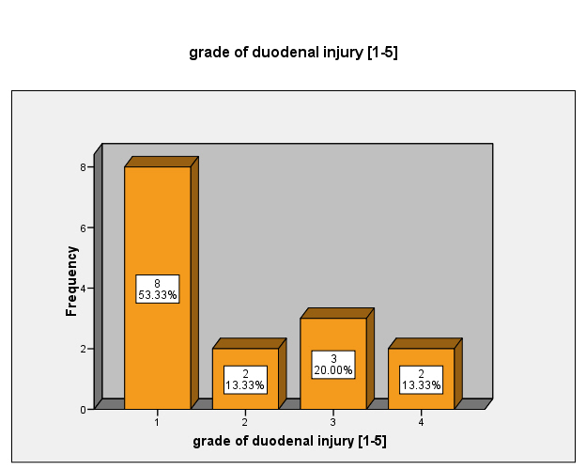
Fig. 1: Grades of duodenal injury (n=15)
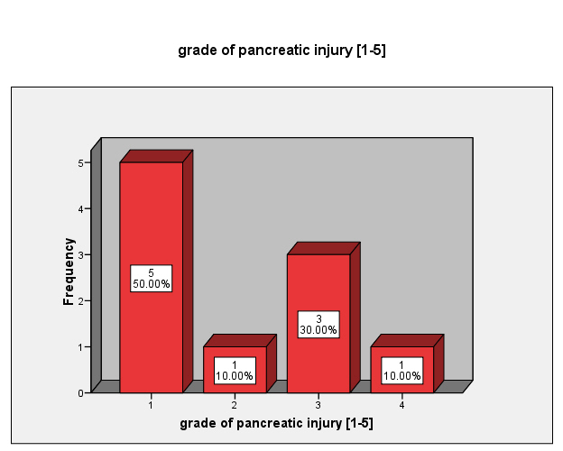
Fig. 2: Grades of pancreatic injury (n=10)

Table: Various available options for operative repair (n=23)
 |  | Frequency | Percent
Valid | Simple drainage + Vigilant watch | 9 | 39.1
 | Distal pancreatectemy+splenectomy | 4 | 17.4
 | Pyloric exclusion | 4 | 17.4
 | Repair of duodenum; in case of <25% circum injury | 4 | 17.4
 | Triple Tube Procedure | 2 | 8.7

RESULTS
During the study period, a total of 196 combat casualities with penetrating abdominal trauma were received in the ‘emergancy reception’ of Combined Military Hospital, Peshawar, Pakistan with injuries due to GSW or explosive mechanism (including IED injuries). All these patients were subjected to emergency laparotomy. Twenty three patients who were having either one or both of pancreatic or duodenal injury were included in study. No case was excluded on basis of presence of associated injury.
Mean age was 29.26 years (SD±6.489) where only one (4.3%) case was female, rest were male patients or soldiers. Thirteen (56.6%) patients had duodenal injuries, 8(34.8%) patients had pancreatic injuries while 2(8.7%) had both duodenal and pancreatic injuries. Nineteen (82.6%) cases had primary mechanism/cause of injury being splinters from IEDs or bomb blasts; while 4 (17.4 %) cases had gunshot wounds. Eighteen (78.3%) patients were haemo-dynamically stable on arrival while 5 (21.7%) patients were unstable. The impact of ‘haemo-dynamic status at time of admission’ ‘delay time’ on mortality is an important factor. In haeom-dynamically stable group 16 (88.9%) patients survived while 2 (11.1%) patients died while in the haemodynamically unstable group 4 (80%) patients died while only 1 (20%) survived. Similarly patients who underwent operative treatment within first 12 hours had less mortality rate as only 1 (5.6%) patient died out of 18, whereas all 5 (100%) patients receiving treatment after first 12 hours succumbed to their injuries. Mean duration of stay in hospital was 10.6 days, (with a range of 1-19 days). It is worth-mentioning that most cases of pancreatico-duodenal injury were of mild severity i.e. grade-1 or 2 (fig 1 and 2) and we encountered no case of grade-5 which required pancreatico–duodenectomy. Most commonly occurring associated injury was to small gut. Table-1 summarizes the various treatments employed. Overall mortality was 6 (26.1%) out of 23 patients. Pancreatico-duodenal mortality, or deaths attributable directly to duodenal or pancreatic injury or its management, occurred in only 1 (4.35%) patient. Other 5 died mainly due to associated injuries especially major vascular injury, head injury or due to increased contamination time in setting of colon and small gut injury.
DISCUSSION
The incidence of pancreatico-duodenal injuries is low and this owes to the anatomical position of these structures. The prevalence of pancreatic injuries has been reported to be 0.4 per 100,000 hospital admissions⁴. In our institution, we followed the rule that every penetrating abdominal trauma mandates laparotomy; to decrease the risk of missed abdominal visceral injury resulting in a catastrophe of complications. A thorough and meticulous exploratory laparotomy with retroperitoneal exploration remains the tool of choice to detect pancreatic and duodenal injuries.
Intra-operative findings that raise suspicion for the presence of a duodenal injury include crepitus along the duodenal sweep, bile staining of para-duodenal tissues, documented bile leak, presence of a right-sided retro-peritoneal or para-renal hematoma. Findings consistent with a pancreatic injury include (central retro-peritoneal haematoma, bile staining in the retro-peritoneum, edema surrounding the pancreas and lesser sac or any pancreatic haematoma or perforation). These findings should never be ignored and must be explained during surgical exploration.
Associated injuries are common with pancreatico duodenal injuries, the incidence of which ranges from 50% to 90%, with a mean of 3.5 organs injured^{5,6}. The most common organs injured are liver (42%), stomach (40%), major vessels (35%), thoracic viscera (31%), colon and small bowel (29%), central nervous system and spinal cord, skeleton and extremities (25%) and duodenum (18%)⁷⁻⁹. Colonic injuries are more common after penetrating injuries^{7,10}. In our study bowel injuries were more common. Mean age in our study was 29.26 years comparable to what was observed by Chinnery and Madiba¹¹ (30.1 years).
Risk factors which have been advocated to determine the final outcome in cases of duodenal injury include pre-operative and intra-operative shock (blood pressure <90 mmHg); an abdominal trauma index >25; associated injuries to the pancreas, superior mesenteric vessels, colon and spleen; and final operating room core body temperature <35⁰C^{12,13}. We found that haemodynamically unstable patients and patients presenting after 12 hours had worse outcomes.
In combined pancreaticoduodenal injuries, management varies and depends on the severity of the injuries of the individual organs. Methods thus employed include; primary repair of duodenal injury and simple drainage of pancreas^{11,14}, distal pancreatectomy with or without spleenectomy^{14,15,16}, pyloric exclusion, enterostomies (triple tube)¹⁴ and pancreaticoduodenectomy^{14,17}. Seventy percent of pancreatic injuries are of grade 1 and 2 which need only simple drainage^{11,14,18}. We observed the same in our study, where majority of the injuries were managed with simple drainage after necessary debridement and repair plus a vigilant watch with highly successful outcome. Reason being that majority of injuries to pancreas and duodenum were of mild severity; which were managed with success keeping in view the damage control principle of surgery in haemodynamically-compromised patients.
CONCLUSION
It is concluded that, the majority of pancreatico-duodenal injuries can be managed by simple repair and efficient drainage. Pyloric exclusion is a useful adjunct for more complex injuries. Pancreato-duodenectomy is rarely necessary and should be avoided in acute setting. Morbidity and mortality following pancreatico-duodenal injuries is primarily related to ‘associated injuries’ especially vascular and hepatic trauma.
References
- Goins WA, Anderson BB. Abdominal trauma revisited. Journal of the National Medical Association. 1991; 83(10):883-8. Epub 1991/10/01.
- Trauma. Feliciano DV, Mattox KL, Moore EE, editors. Norwalk, Conn. Appleton & Lange; 1988.
- Gomez-Leon JF. Original Article-Penetrating abdominal trauma index: sensitivity and specificity for morbidity and mortality by ROC analysis. 2004.
- Nilsson E, Norrby S, Skullman S, Sjödahl R. Pancreatic trauma in a defined population. Acta Chir Scand. 1986; 152:647-51.
- Jurkovich GJ, Carrico CJ. Pancreatic trauma. The Surgical clinics of North America. 1990; 70(3):575-93. Epub 1990/06/01.
- Stone HH, Fabian TC, Satiani B, Turkleson ML. Experiences in the management of pancreatic trauma. The Journal of trauma. 1981;21(4):257.
- Wilson R, Moorehead R. Current management of trauma to the pancreas. British Journal of Surgery. 1991; 78(10):1196-202.
- Frey CF, Wardell JW. Injuries to the pancreas. In: Trede M, Carter DC eds. Surgery of the pancreas. Edinburgh: Churchill Livingstone; 1993. p. 565– 89.
- Feliciano DV, Martin TD, Cruse PA, Graham JM, Burch JM, Mattox KL, et al. Management of combined pancreatoduodenal injuries. Ann Surg 1987; 205: 673-80.
- Lancy KE. Review of pancreatic trauma. Western Journal of Medicine. 1989; 151(1):45.
- Chinnery GE, Madiba TE. Pancreaticoduodenal injuries: re-evaluating current management approaches. S Afr J Surg 2010; 48:10-14.
- Timaran CH, Martinez O, Ospina JA. Prognostic factors and management of civilian penetrating duodenal trauma. J Trauma. 1999; 47(2):330-5.
- Blocksom JM, Tyburski JG, Sohn RL, Williams M, Harvey E, Steffes CP, et al. Prognostic determinants in duodenal injuries. Am Surg. 2004; 70(3):248-55.
- Degiannis E, Glapa M, Loukogeorgakis SP, Smith MD. Management of pancreatic trauma. Injury. 2008; 39(1):21-9.
- Degiannis E, Levy RD, Potokar T, Lennox H, Rowse A, Saadia R. Distal pancreatectomy for gunshot injuries of the distal pancreas. Br J Surg. 1995; 82(9):1240-2.
- Cogbill TH, Moore EE, Morris JA, Jr., Hoyt DB, Jurkovich GJ, Mucha P, Jr., et al. Distal pancreatectomy for trauma: a multicenter experience. J Trauma. 1991; 31(12):1600-6.
- Walt AJ. Commentary. In: Ivatury RR, Gayten GG, eds. The Textbook of penetrating trauma. Baltimore, Maryland: Williams and Wilkins, 1996: 641—2.
- Krige JE, Beningfield SJ, Nicol AJ, Navsaria P. The management of complex pancreatic injuries. S Afr J Surg. 2005; 43(3):92-102.

