ROLE OF SONOURETHROGRAPHY IN EVALUATION OF ANTERIOR URETHRAL STRICTURE AND ITS COMPARISON WITH RETROGRADE URETHROGRAPHY
Muhammad Babar Khan, *Rashid Mahmood, **Abdul Ghaffar, ***Tariq Mahmood
144 (I) Field Ambulance, *Combined Military Hospital Skardu, **PNS Shifa Karachi, ***JPMC Karachi
ABSTRACT
Objective: The aim of this study was to compare retro grade urethrography (RUG) and sonourethrography (SUG) for assessment of urethral strictures and to evaluate whether RUG underestimates stricture length, as has been reported.
Study design: Quasiexperimental study.
Place and Time of Study: The study was performed in the department of Radiology PNS Shifa Karachi from January 2004 till December 2004.
Patients and Methods: Forty male patients diagnosed with anterior urethral stricture were assessed for presence of strictures and their length by conventional contrast urethrography and sonourethrography. Contrast urethrography was carried out by retrograde injection of Urograffin 76% under fluoroscopic guidance. Sonourethrography was done with a 7.5 MHz small parts transducer. Stricture lengths were recorded and compared.
Results: Analysis of the results showed that the estimation of stricture length measured by contrast urethrography was under-estimated as compared to sonourethrography. The difference between the two tests was significant (P < 0.001) and the correlation coefficient was poor (r = 0.493). When the strictures were grouped into penile and bulbar anatomical locations the results remained highly significant in the bulbar region (P = 0.0001) however no significant difference was found in the estimated length for penile strictures (P = 0.25).
Conclusion: Sonourethrography is a good adjunct investigation before definitive surgical therapy particularly in the bulbar region where conventional contrast urethrography was shown to underestimate stricture length significantly.
Keywords: Sonourethrography (SUG), retrograde urethrography (RUG), urethral stricture.

INTRODUCTION
The male urethral imaging and pathology is not widespread in the radiology literature because this part of the urinary tract is easily studied by urologists with clinical or endoscopic examinations. Voiding cystourethrography and retrograde urethrography imaging have increasingly being used for diagnosis of urethral strictures. Now new imaging techniques in this area, such as sonography can provide adjunct information that cannot be obtained with other modalities [1,2]. Estimation of length of stricture is an important determinant for the selection of most optimal surgical procedure i.e. internal urethrotomy versus dilatation [3]. Despite the practicality of conventional techniques, inherent limitations of RUG do exist. In addition to exposing the patients to radiation and the potential risk of severe reactions to the contrast medium, variation in patient position and penile traction during imaging can greatly alter the radiographic appearance of the urethra and the stenotic area. Stricture length in the anterior urethra is often underestimated [4,5]. To overcome the constrains of conventional radiographic technique and better define the extent of urethral stricture disease, the use of ultrasonography to image the male urethra was started in 1985. A lot of research work has appeared in the literature on the subject [6,7] but little data is available on this important subject in Pakistan.
Correspondence: Maj Rashid Mahmood, Graded Radiologist, Combined Military Hospital, Skardu.
PATIENTS AND METHODS
Table-1: Anterior urethral stricture length comparison between RUG and SUG.

Patient No | Location of Stricture | RUG Length in mm | SUG Length in mm
1 | B | 15 | 39.5
2 | B | 5 | 6.7
3 | B | 10 | 12
4 | B | 5 | 9.9
5 | B | 25 | 33.7
6 (a) | B | 5 | 5.8
(b) | B | 20 | 5
7 | B | 10 | 10
8 | B | 20 | 40
9 | P | 20 | 10
10 | B | 5 | 12
11 | B | 10 | 19.7
12 | P | 25 | 28.7
13 | B | 5 | 8
14 | PSJ | 15 | 21.3
15 | P | 10 | 12
16 | B | 10 | 9.1
17 | P | 10 | 7.9
18 | B | 15 | 29.1
19 | B | 5 | 8
20 | P | 20 | 18.7
21 | B | 30 | 25
22 (a) | PSJ | 20 | 9.8
(b) | P | 10 | 7.3
23 | B | 5 | 20.6
24 | B | 10 | 8
25 | B | 15 | 28.7
26 | B | 5 | 5
27 | B | 15 | 34.1
28 | B | 5 | 10.7
29 | B | 22 | 25
30 | B | 10 | 29.9
31 | P | 25 | 23.2
32 | P | 10 | 6.9
33 | B | 5 | 20.2
34 | P | 5 | 7.3
35 | B | 5 | 15.5
36 (a) | B | 6 | 33
(b) | B | 5 | 10.1
37 | P | 30 | 29.8
38 | P | 15 | 13.7
39 | B | 10 | 28.5
40 | B | 10 | 21.3
Mean |  | 12.512 | 17.691

B: Bulbar, P: Penile, PSJ: Penoscrotal junction.
A total of 40 patients referred from urologists to Radiology Department of PNS Shifa Karachi for urethrography from January 2004 to December 2004 were included in this study. Age of all the patients was between 17 to 61 years with mean age 37 years. Consent from all patients was taken for the subject procedures. Patients with posterior urethral strictures were excluded from the study. Patients in whom conventional urethrography did not adequately demonstrate the diseased urethral segment due to failure of passage of contrast beyond the stricture site despite combined antegrade approach were also excluded from the study. Sonourethrography was performed without prior knowledge of the findings of retrograde urethrography.
Urethrogram was performed by retrograde injection of Urograffin 76% and taking x-ray films in different projections on Toshiba Multipurpose x-ray system Model KXO-50 M (Japan). Sonourethrography was performed with 7.5 MHz linear array small parts transducer using Toshiba SONOLAYER SSH-140A. The glans penis and urethral meatus was disinfected and the transducer applied directly over the ventral surface of the penis, scrotum and the perineum after ultrasound gel application. Saline solution was slowly and repeatedly installed by means of an appropriate catheter tip syringe in the urethral meatus. In cases where it was not possible to catheterize the patient due to meatal stenosis, an appropriate size feeding tube was used to infuse the contrast material. Simultaneous real-time images of the urethra were obtained sequentially from the pendulous urethra proximally towards the deep bulbar area. Sonourethrographic findings were correlated with conventional contrast urethrography and the results recorded.
The presence of strictures and their locations as determined by conventional and sonourethrography, were compared by cystourethroscopy in all patients. Five patients who underwent open urethroplasty were available for direct measurement of stricture length and their comparison with the findings of urethrography and sonourethrogrphy.
Table-2: Penile urethral stricture length comparison between RUG and SUG.

Patient No | RUG Length in mm | SUG Length in mm
9 | 20 | 10
12 | 25 | 28.7
15 | 10 | 12
17 | 10 | 7.9
20 | 20 | 18.7
22(b) | 10 | 7.3
31 | 25 | 23.2
32 | 10 | 6.9
34 | 5 | 7.3
37 | 30 | 29.8
38 | 15 | 13.7
Mean | 16.364 | 15.045

Table-3: Bulbar urethral stricture length comparison between RUG and SUG.

Patient No | RUG  Length in mm | SUG  Length in mm
1 | 15 | 39.5
2 | 5 | 6.7
3 | 10 | 12
4 | 5 | 9.9
5 | 25 | 33.7
6 (a) | 5 | 5.8
(b) | 20 | 5
7 | 10 | 10
8 | 20 | 40
10 | 5 | 12
11 | 10 | 19.7
13 | 5 | 8
14 | 15 | 21.3
16 | 10 | 9.1
18 | 15 | 29.1
19 | 5 | 8
21 | 30 | 25
22 (a) | 20 | 9.8
23 | 5 | 20.6
24 | 10 | 8
25 | 15 | 28.7
26 | 5 | 5
27 | 15 | 34.1
28 | 5 | 10.7
29 | 22 | 25
30 | 10 | 29.9
33 | 5 | 20.2
35 | 5 | 15.5
36 (a) | 6 | 33
(b) | 5 | 10.1
39 | 10 | 28.5
40 | 10 | 21.3
Mean | 11.188 | 18.600

All statistics were calculated on SPSS version 10. The hypothesis was tested for significance by the t test. P value of less than 0.05 was considered statistically significant.
RESULTS
Out of total 40 patients, three (7.5%) were having multiple strictures. Mean estimated length by RUG was 12.512 mm as compared to 17.691 by SUG (table-1). Analysis of the results showed that when the stricture length measured by sonourethrography was compared with the measurements on conventional urethrography the difference between the two tests was significant (P < 0.001) and the correlation coefficient was poor (r = 0.493).
In penile strictures the mean estimated length by RUG was 16.364 mm as compared to 15.045 mm by SUG (table-2). In Bulbar strictures the mean estimated length by RUG was 11.188mm as compared to 18.600 mm by SUG (table-3). Thus when the strictures were grouped into penile and bulbar anatomical locations the results remained highly significant in the bulbar region (P = 0.0001) however no significant difference was found in the estimated length for penile strictures (P = 0.25).
Five patients who underwent open urethroplasty were available for direct measurement of stricture length. In all these patients sonourethrography defined the stricture length more precisely then conventional urethrography (table-4).
DISCUSSION
Table-4: Anterior urethral stricture length comparison between RUG, SUG and per-operative findings.

RUG Length mm | SUG  Length mm | Per-operative Length mm
15 | 21.3 | 21.3
5 | 15.5 | 16
10 | 19.7 | 20
5 | 10.1 | 12
5 | 10.7 | 12

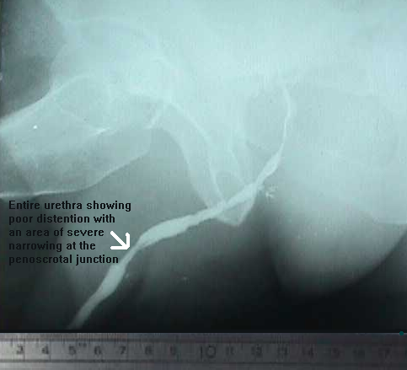

Fig. 1: Retrograde urethrogram showing a focal stricture measuring 15 mm at Penoscrotal junction of patient No 14.

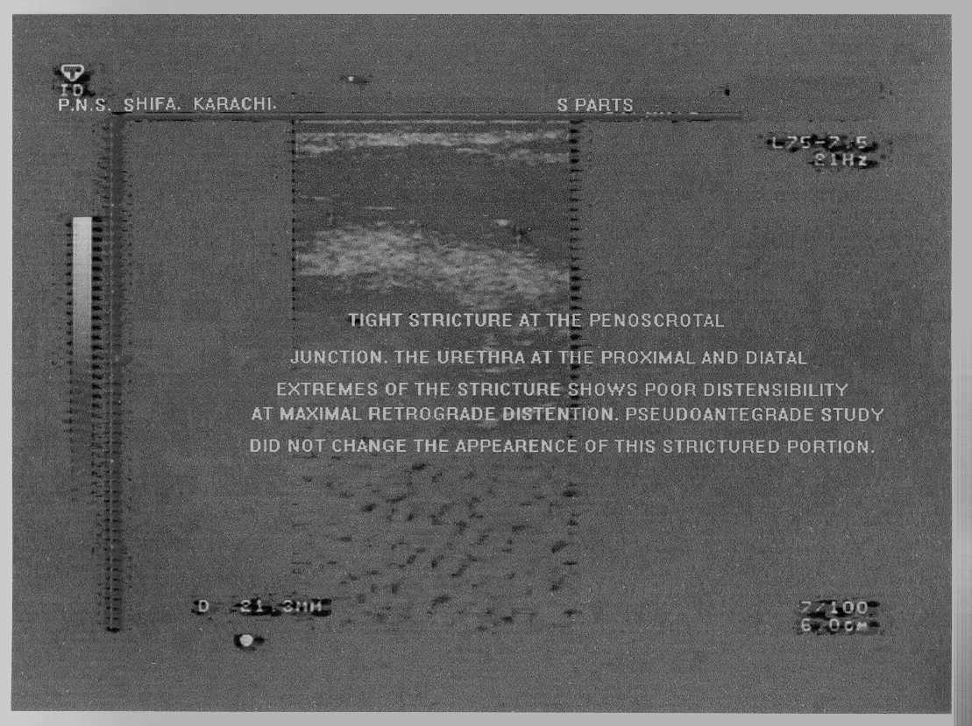

Fig. 2: Sonuurethrography showing the stricture measuring 21.3 mm of the same patient.

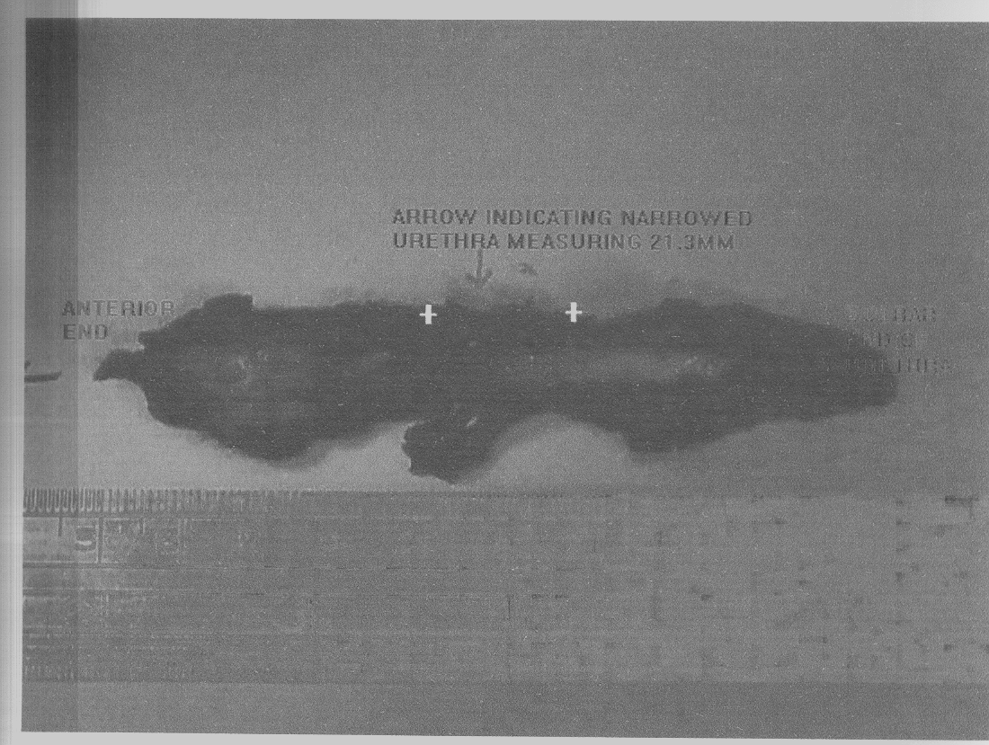

Fig. 3: Respected specimen of the same patient showing the diseased urethra measuring 21.3 mm.
Assessment of length of stricture is an important criterion for selection of surgical procedure particularly for bulbar strictures. Earlier investigators, using conventional contrast urethrography proposed that only strictures 1cm or less be selected for excision therapy [8]. McAninch et al started sonourethrogrphy in 1985 at San Francisco General Hospital to study urethral strictures length estimation [9]. They demonstrated that radiographic technique consistently underestimated the length of anterior urethral strictures compared to intraoperative measurements, while sonourethrography correlated well. Using a 5 MHz linear probe in their earlier studies they showed that the strictured area remained rigid during retrograde installation of saline while normal urethra distended easily. In 1988, two other small series described their preliminary experience with the technique [10,11]. In 1998 a study of 52 patients was carried out in Pakistan [12]. This study concluded that sonourethrography is an inexpensive and radiation free procedure, which can be performed on an outdoor basis. Limitations of the study included poor visualization of posterior urethra and failure to demonstrate false passages. Another study revealed that RGU showed a lower sensitivity (60–80%) for lengths 1–4 cm, compared with sonourethrography (73.3–100%) [13].
In our study forty patients with RUG findings suggestive of stricture disease were correctly identified by sonourethrography. In majority of cases only one stricture was present at the time of the study but in three (7.5%) synchronous strictures were imaged and available for comparison. Analysis of the results showed that when the stricture length measured by sonourethrography was compared with the measurements on conventional urethrography the difference between the two tests was significant (P < 0.001) and the correlation coefficient was poor (r = 0.493). The presence of stricture and their locations, as determined by conventional and sonourethrography, was confirmed by cystourethroscopy.
On grouping the stricture by their anatomical site (penile and bulbar) and repeating the comparison, the correlation was better (r= 0.909) and the difference was not significant (P = 0.256) when the stricture was located in the penile region. However in the bulbar region the correlation remained poor (r = 0.481) and the significant difference remained (P < 0.0001). The results show a statistically significant difference in the length of anterior urethral strictures on comparison to conventional contrast urethrography in the region of the bulbar urethra; thereby proving the hypothesis that the foreshortening due to the curved anatomical course of the bulbar urethra and the radiographic position necessary for its assessment leads to significant shortening of the visualized length on conventional urethrography and the technique should not be relied upon for measuring stricture length in the anterior urethra. Morey A F et al in 1997 studied the accuracy of sonourethrography in strictures of the bulbar urethra in order to define the role of preoperative sonourethrography in establishing objective criteria for procedure selection for management of bulbar urethral strictures [14]. Based on these and other studies several authors recommend excision therapy with end-to-end anastomosis for strictures sonographically measuring up to 25 mm [15,16].
Five patients who underwent open urethroplasty were available for direct measurement of stricture length. Patient No 14, who was having stricture at Penoscrotal junction, was operated and its measurements on RGU, SUG and after resection were 15mm, 21.3 mm and 21.3 mm respectively. These have been shown in (fig. 1-3). Our study suggests that there is a significant difference in length estimation between conventional and sonourethrography. The no of operative cases available for direct measurements is limited but its correlation with the limited no of cases that have appeared in international literature was excellent. Nash et al, in 1995 compared stricture length using conventional techniques and sonourethrography to peroperative findings. They determined that sonourethrographic estimates closely correlated with intraoperative lengths whereas retrograde urethrography length did not [17]. Sonourethrography was thus shown to overcome the limitation of conventional radiographic procedure of retrograde urethrography, which showed an end on view of bulbar stricture resulting in reduction in the apparent length of the stricture.
CONCLUSION
Sonourethrography is a simple and safe technique and provides comparable efficiency to urethrography in detection of anterior urethral stricture disease. Sonourethrography can determine length more accurately than any standard radiographic procedures. It can provide useful information particularly in patients in whom the need for definitive surgical treatment is clear.
REFERENCES
- Pavlica P, Barozzi L, Menchi I. Imaging of male urethra. European Radiology 2003; 13: 1583-96.
- Peskar DB, Perovi AV. Comparison of radiographic and sonographic urethrography for assessing urethral strictures. European Radiology 2004; 14: 137-44.
- Steenkamp J W, Heyns C F, Kock M L. Internal urethrotomy versus dilation as treatment for male urethral strictures: a prospective, randomized comparison. J Urol 1997; 157: 98-101.
- Galantine M L, Morey A F. Imaging of the male urethra for stricture disease. Urol Clin N Am 2002; 29: 361-72.
- Berman LH, Bearcroft PW, Spector S. Ultrasound of the male anterior urethra. Ultrasound 2002; 18: 123-33.
- Merkle W, Wagner W. Sonography of the distal male urethra. A new diagnostic procedure for urethral strictures: Results of a retrospective study. J Urol 1988; 13: 140-47.
- Pushkarna R, Bhargava S K, Jain M. Ultrasonographic evaluation of abnormalities of the male anterior urethra. Ind J Radiology Imag 2000; 10: 89-91.
- A. Harding R, H. David R. ed’s. Bailey and Love’s short practice of surgery. London H K Lewis 2000: 1333-8.
- Mc Aninch J W, Laing F C, and Jeffrey R B. Sonourethrography in the evaluation of urethral strictures: A preliminary report. J Urol 1988; 139: 294-7.
- Gluck C D, Bundy A L, Fine C, Loughlin K R, Richie J P. Sonographic urethrogram: comparison to roentgenographic techniques in 22 patients. J Urol 1988; 140: 1404- 08.
- Merkle W, Wagner W. Sonography of the distal male urethra. A new diagnostic procedure for urethral strictures: Results of a retrospective study. J Urol 1988; 31: 140-5.
- Sardar Q, Saddiqi MAJ. Role of Sonourethrography in the Diagnosis of Urethral Strictures and its comparison with Retrograde Urethrography. Ann King Edward Med Coll 1998; 4: 53-5.
- Choudhary S, Singh P, Sundar E, Kumar S and Sahai A. A comparison of sonourethrography and retrograde urethrography in evaluation of anterior urethral strictures. Clinical Radiology 2004; 59:736-42.
- Morey A F, McAninch J W. Role of preoperative sonourethrography in bulbar urethral reconstruction. J Urol 1997; 158: 1376- 9.
- Heindenreich A, Derschum W, Bonfig R, Wilbert D M. Ultrasound in the evaluation of urethral stricture disease: A Prospective study in 175 patients. Br J Urol 1994; 74: 93-8.
- Morey A F, McAninch JW. Sonographic staging of anterior urethral strictures. J Urol 2000; 163: 1072-9.
- Nash P A, McAninch J W, Bruce J E, Hanks D K. Sono-urethrography in the evaluation of anterior urethral strictures. J Urol 1995; 154: 72-6.

