ROLE OF CAROTID DOPPLER IN CORONARY ARTERY DISEASE

Shamrez Khan, *Syed Afzal Ahmed, *M.M.H Nuri, *Muhammad Khalid, *Azhar Rashid, *Azhar Mehmood, *Asif Ali, *Muhammad Bilal Bin Yousaf, *Muhammad Ashraf Farooq, Muhammad Nafees, *Irfan Ul Haq, *Shazia Ashfaq

Military Hospital Rawalpindi, *AFIC/NIHD Rawalpindi

ABSTRACT

Objective: To find out the Intima media thickness (IMT) of carotid artery disease in coronary artery disease and to identify hemodynamically significant stenosis (i.e.>70%) in patients undergoing coronary artery bypass surgery.

Design: A descriptive study.

Place & Duration of Study: The study was conduct at AFIC & MH Rawalpindi from 2003 to 2004.

Patients and Methods: One hundred patients of triple, double and single vessel coronary artery disease were studied. There were 85 male and 15 female patients, ranging from 35 to 77 years. The patients were studied by Toshiba Ultrasound Machine equipped with high frequency linear transducers. In 10 patients having more that 70 % ICA stenosis, conventional angiography was done.

Results: Intima-media thickness of common carotid artery was increased in 92 patients with mean value of 1.1 mm. Plaques were seen in 92 patients with commonest location at carotid bifurcation with extension into the origin of ICA. 15 patients has >70%, 10 patients > 50 % stenosis and 67 patients in the range of 1-50 % stenosis. 6 patients showed normal intima-media thickness with no evidence of plaque. In two patients ultrasound could not locate bifurcation of CCA. Doppler ultrasound showed 98 % sensitivity in diagnosis of > 70 % stenosis.

Conclusion: Doppler ultrasound is a non-invasive imaging modality of choice in evaluation of extra-cranial carotid artery disease.

Keywords: Doppler, plaque, stenosis.

INTRODUCTION

Carotid Doppler is widely used to estimate the degree of luminal narrowing in carotid arteries. The carotids provide a convenient window for the assessment of whole arterial system. Pattern of development of atheroma may vary for different arterial areas. In approximately two thirds of patients with symptoms of cerebrovascular insufficiency disease of extracranial carotid arterial system, mainly the carotid bifurcation, is the most frequent site of plaques producing embolism and cerebral infarction [1,2]. There is also high association between CCA intima-media thickness, ICA stenosis and severity of coronary artery disease [3,4,5]. The biggest advantage of ultrasound is its non-invasive nature and ability to characterize and identify plaques with high risk of embolization, which is not possible with any other technique. So, endarterectomy can be done before coronary artery bypass surgery to reduce the peri-operative morbidity as a result of emboli or inadequate perfusion. The objective of the study is to find out the frequency and diagnosis of hemodynamically significant stenosis (>70% diameter reduction) of extracranial carotid arteries in severe coronary artery disease, and to establish relationship between intima-media thickness (IMT) of carotid arteries and extent of coronary artery disease.
Correspondence: Col Shamrez Khan, Classified Radiologist, Military Hospital, Rawalpindi.

PATIENTS AND METHODS

A study was conducted at AFIC & MH Rawalpindi from 2003 to 2004. The study included 100 patients of coronary artery disease diagnosed by coronary angiography. Patients age, sex, any history of hypertension, Diabetes mellitus, smoking, TIA or frank stroke and bruits were noted. They were examined in supine position with head and shoulder lying on pillow and neck extended to allow full access to the neck and supraclavicular area. Bilateral carotids and vertebral arteries were examined by Toshiba APLIO SSA-700 and Toshiba Power Vision 6000 ultrasound machines using linear transducer 7.5-11 MHz with gray-scale, pulsed and color Doppler flow. The examination started with transverse scan of common carotid artery (CCA) from as low in neck as possible to as high in neck as possible behind the angle of mandible where the artery bifurcates into internal carotid artery (ICA) and external carotid artery (ECA). These vessels were also examined in longitudinal plane through antero-lateral, lateral and posterior approach. Identification of the ECA & ICA was made on following features. The ECA was nearly always anterior to carotid artery and had branches above bifurcation. It showed low diastolic flow and prominent dichrotic notch on spectral Doppler pulse waveform. In cases where differentiation from ICA was difficult superficial temporal artery tapping was done over zygoma by finger which produced rapid clear fluctuations in the wave form in the ECA whereas there was little or no effect in the ipsilateral CCA & ICA. The ICA was the more posterior of the two branches and seen in continuously with CCA. It was larger in caliber and showed high diastolic flow on spectral Doppler waveform. The image was magnified for intima-media thickness (IMT) measurement, taken along the posterior wall of straight segment of the distal CCA, appearing as a bright line near the wall, (normally value = <0.8 mm). The measurement of the degree of stenosis was made by:-

Direct measurement of true and residual lumen of vessel at the site of maximum stenosis by plaque was done in longitudinal and transverse planes, using both gray-scale and color Doppler. The percentage diameter stenosis was calculated (fig. 1).

Doppler spectral waveforms were obtained at the site of maximum stenosis in ICA, straight segment of CCA and ECA. All measurements were made by using angle of insonation less than 600. With the use of electronic callipers,. Peak systolic velocity (PSV) and end-diastolic velocity (EDV) values were recorded respectively for all waveforms. ICA/CCA peak systolic velocity and end-diastolic velocity ratios were calculated. The degree of stenosis was calculated by using (table-1) Buth et al and (table-2) made by Robinson et al.

In 10 patients with more than 70% stenosis of ICA, bilateral four-vessel neck (carotids & vertebrals) angiography was done to correlate the ultrasound results. North American Symptomatic Carotid Endarterectomy Trial (NASCET) and European Carotid Surgery Trial (ECSR) were used for calculating the degree of angiographic diameter stenosis. In NASCET method a residual lumen diameter at the most stenotic portion of the vessel was measured and compared to the lumen diameter in the normal ICA distal to stenosis. The ECST method measured the lumen diameter at the most stenotic portion of the vessels and compared to estimated probable original diameter at the site of maximum stenosis.

STATISTICAL ANALYSIS

The date was stored and analyzed using SPSS version 10.0. Descriptive statistics, comprising means, standard deviations and percent change were calculated for all variables.

RESULTS

The minimum age in study was 35 years and maximum being 77 years. Severe coronary artery disease was found to be more between 60-70 years age group (52 patients). Out of 100 patients 38 were diabetics, 37 hypertensive and 35 were smokers. 86 patients had triple vessel coronary artery disease (TVCAD), 18 had double vessel coronary artery disease (DVCAD) and 2 had single vessel coronary artery disease (SVCAD). The predominantly involved artery on coronary angiography was left anterior descending artery (LAD) in 82 patients while in remaining 18 patients, right coronary artery (RCA) was critically stenosed.

The intima-media thickness (IMT) was increased in all patients of TVCAD, ranging from 0.9 to 1.6 mm. 6 patients showed normal IMT. The mean IMT was 1.1 mm. In 92 patients plaques were identified with unilateral to bilateral ratio of 54:38. The commonest site of location was carotid bifurcation with extension into origin of internal carotid artery (ICA) (table-1). 20 patients showed extension into external carotid artery (ECA) 80 plaques were heterogeneous predominantly echogenic, and 12 were homogeneous.

15 patients had more than 70% stenosis of origin of ICA, including 5 cases of complete unilateral and one case of bilateral ICA occlusion. 10 cases of > 50% ICA stenosis were detected. 67 cases showed < 50 % stenosis. 6 cases were normal (table-4). In 2 patients internal carotid artery could not be visualized due to high bifurcation of common carotid artery.

PSV was more than 2.3 m/sec and 1.5 m/sec in > 70% and > 50 % stenosis, respectively (fig. 2). ICA/ CCA PSV ratio was more than 3 in > 70% and more than 2 in > 50 % stenosis (fig. 3). In < 50% stenosis, peak systolic velocity was less than 1.25 m/sec. Up to 60 % stenosis, no change was observed in end-diastolic velocity. It was increased (> 75 cm/sec) in patients having more than 70 % stenosis.

DISCUSSION

Many techniques have been developed to diagnose carotid artery disease, often enabling surgeons to intercede before the plaque progresses to point of occlusion or imminent stroke. Carotid angiography remains the gold standard for diagnosing these conditions, but our study shows that Doppler ultrasound is as accurate as angiography.

In our study of 100 patients, ultrasound accurately localized the site of plaque leading to luminal narrowing. The commonest site of plaques was carotid bifurcation extending into proximal part of internal carotid artery. We found diameter stenosis measurement quicker and easier to perform as compared to area stenosis (fig. 1) [6]. However, in eccentric plaque, area stenosis should be calculated which time is consuming.

It was observed that 50% diameter stenosis corresponds to 70% area stenosis. So misinterpretation of 70% area stenosis as diameter stenosis will result in significant overestimation in assessment of calibre reduction possibly leading to unwarranted surgery [2,7]. We restricted ourselves to diameter stenosis, which co-relates well with Doppler criteria for stenosis calculation.

In complex plaques color and spectral Doppler was used to quantify the degree of stenosis. Carefully calculated velocity Doppler criteria correlated well with the degree of narrowing [8,9]. Peak systolic velocity in ICA and ratio of peak systolic velocity (PSV) in internal carotid artery (ICA) to PSV in common carotid artery (CCA) were more useful measurement tools. A decreasing trend of peak systolic velocity (PSV) was noted along the course of CCA towards bifurcation; so peak systolic velocity should be taken at proper sites in ICA and CCA for ratio measurement. PSV in ICA should be taken at the site of maximum narrowing and in CCA at straight mid to distal segment.

Table-1: Bluth et al [8] doppler spectral analysis: carotid artery disease-diagnostic parameters.

Diameter stenosis | Peak systole  ICA/stenosis | Peak diastole  ICA/Stenosis | Systolic velocity ratio | Diastolic velocity ratio | Flow character ICA/ stenosis
0-39% |  |  | <1.8 |  | Normal-mild spectral broadening
Normal-mild | <110 cm/s | <45 cm/s
40-59% |  |  | <1.8 | <2.6 | Mild-moderate spectra l broadening
Moderate | 110-150 cm/s | <45 cm/s
60-79% |  |  | 1.8-3.7 | 2.6-5.5 | Moderate-severe spectral broadening
Severe | 150-250 cm/s | 45-140 cm/s
80-99% |  |  | >3.7 | >5.5 | Severe spectral broadening
Critical | 250-615 cm/s | >140 cm/s
99% | Extremely low | N/A | N/A | N/A | Highly turbulent loss of normal cardiac cycle
Critical
100% | N/A | N/A | N/A | N/A | N/A
Total | (CCA diastolic
Occlusion | Flow is zero)

Table-2: Robinson et al [9] Diagnostic criteria for doppler diagnosis of stenosis of 50% & 70 %.

Diameter Stenosis % | PSV ICAª ms⁻¹ | EDV ICAª ms⁻¹ | IC/CC systolic ratio
50 | >1.5 | >0.5 | >2
70 | >2.3 | >0.75 | >3

Vertebral arteries were also examined after being located between transverse processes using color and spectral flow.

Table-3: Classification of carotid plaques.

Haemodynamic Classification
H1 | 0-20% Diam, reduction | Normal to mild
H2 | 20-60% Diam, reduction | Moderate
H3 | 60-80% Diam, reduction | Severe
H4 | 80-99% Diam, reduction | Critical
H5 | Occluded
Morphological components
P1 | Homogeneous
P2 | Heterogeneous
Surface characteristics
S1 | Smooth
S2 | Irregular (defect <2 mm)
S3 | Ulcerated (defect >2 mm)

Plaque characterization was made by using table 3 proposed by Thiele et al.

Table-4: Percentage stenosis of ICA in 100 patients.

No. of Cases | Normal | 1.50 % | >50 % | > 70 %
No. of Cases | 6 | 67 | 10 | 15

In two cases carotid bifurcation was not identified on ultrasound.

Color Doppler is extremely helpful in taking the spectral waveform from exact site of narrowing with the placement of sample volume. It also helps a lot in accurate assessment of diameter stenosis because it tells the true lumen of vessel while on gray-scale imaging soft plaque can be missed and vessel lumen may appear free of any plaque [10].

Angle of insonation with proper sample volume was seen to be an important factor in doppler spectral measurements. Incorrect angle (70o-90o) can lead to poor quality spectral flow with evidence of signal both above and below the base line. A poor angle also leads to inadequate color filling of vessels (color is also pulsed Doppler). We found that angle between 40o-60o is optimal for imaging vessels [6].
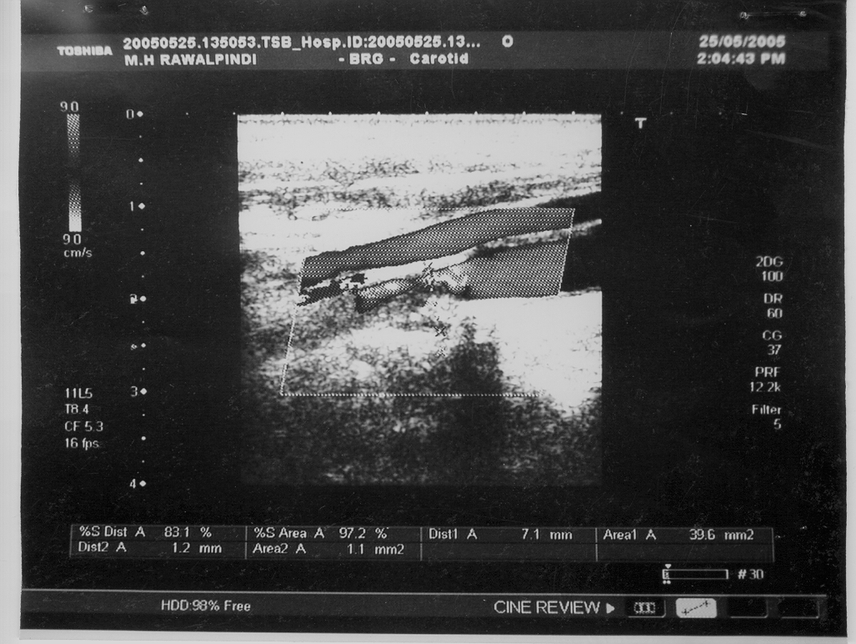
Fig. 1: ICA showing 83% diameter stenosis at origin due to heterogenous plaque extending from bifurcation of CCA.

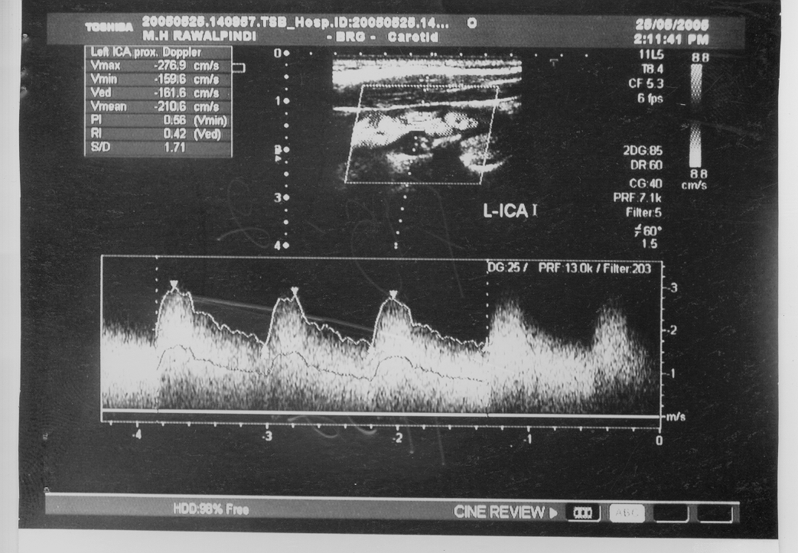
Fig. 2: Stenosis of ICA >70% showing PSV 276.9 cm/sec.

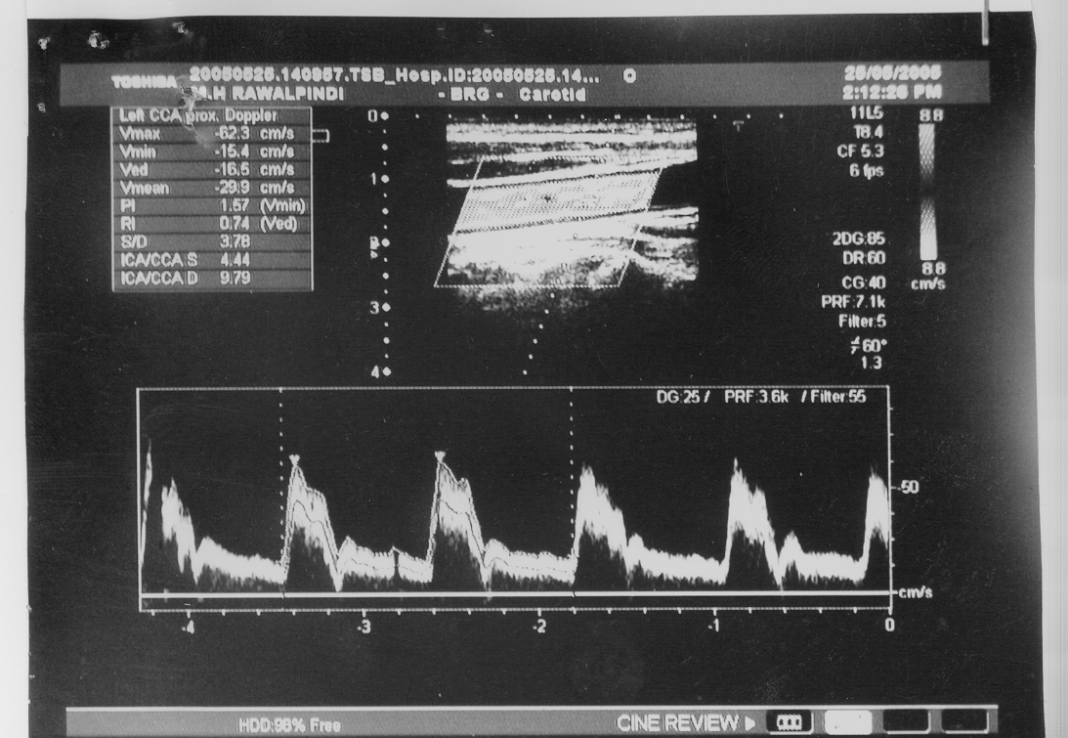
Fig. 3: >70% stenosis of ICA showing ICA/CCA (PVS) ratio of 4.44.

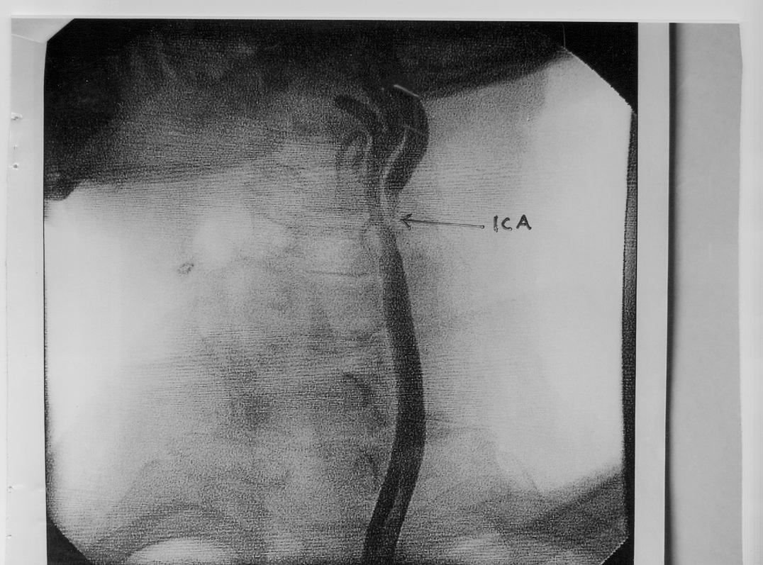
Fig. 4: Carotid angiogram shows >90% stenosis of ICA at origin. ECA is normal with side branches.

In patients having less than 50% diameter stenosis, we followed Buth et all criteria [8]. Peak systolic velocity of ICA and PSV ratio of ICA/CCA did not correlate in our patients with these criteria. Peak systolic velocity of ICA was within normal range in most cases with plaques causing < 50 % diameter stenosis. So we relied only on direct measurement of diameter stenosis. The main levels which need to be distinguished were >50 % diameter reduction, where blood flow starts to decline and 70 % diameter reduction, which is the level strongly associated with clinical symptoms and for which carotid endarterectomy would be considered. Our results closely correlated with Robinson et al criteria which is more accurate and practical for calculation of > 50% and > 70 % diameter stenosis (table-2) [2,8]. End diastolic velocity and spectral broadening did not add much in stenosis measurement. However, proportionate spectral broadening was noticed with degree of stenosis along with increased end-diastolic velocity.

Differentiation of high-grade stenosis and complete occlusion of ICA is very important because occlusion is not amenable to surgical treatment. Use of color and power doppler was extremely useful to detect any trickle of blood flow [11]. Secondary signs found with complete occlusion were increased blood flow in ipsilateral ECA and contralateral CCA and ICA. It is very important not to label ECA as ICA because flow in ECA is internalized due to development of collaterals between ECA and ICA in ICA occlusion. Here temporal artery percussion test can be used for confirmation of ECA [10].

A close correlation between severity of coronary artery disease and extra-cranial carotid artery disease was found. 92 patients of coronary artery disease showed increased IMT. The maximum IMT was 1.6 mm with a mean value of 1.1 mm. 6 patients showed normal IMT without any evidence of plaque. These results showed that IMT increases with advancing age and patients having 1.1 mm IMT have 92 % likelihood of having severe coronary artery disease. Our results are close to international studies regarding association of coronary artery disease and IMT. In a study done by Ebrahim S and his colleagues IMT of CCA (> 1.05mm) and plaques are directly associated with ischemic heart disease risk factors and prevalent ischamic heart disease [1]. So it is suggested that IMT can be used as a non-invasive surrogate end point to measure progression of atherosclerosis [4,5,12]. The commonest site of plaque formation was carotid bifurcation with extension into ICA. In 80 patients plaques were seen at the origin of internal carotid artery and in 20 % at external carotid artery origin. 80 % plaques were heterogeneous predominantly echogenic and 20%, hemogeneous. Hemodynamically significant plaques H3S2P2 and H5S2P2 were seen in 15 patients causing >70 % stenosis of ICA. Unilateral versus bilateral ratio was 54:38. The increased echogenicity of plaques were due to lipid lowering drugs which cardiac patients were using. These drugs reduce serum lipid levels and lipid content of plaque making the plaque more stable and echogenic [13]. Only in 20 patients serum triglycerides and in 5 patients serum cholesterol was raised.

To check the accuracy of Doppler ultrasound conventional angiography was done in 10 patients having >70 % stenosis. NASCET and ECST technique was used to calculate diameter stenosis on angiography [14,15]. The results were extremely encouraging showing the Doppler ultrasound as accurate as angiography (fig. 4). We observed that an 80 % ECST diameter stenosis for the given lesion corresponds to a stenosis of 50% in the NASCET method for the same lesion. So we followed NASCET method which was comparable with our Doppler results. The study carried by Hood DB and his colleagues to identify 70% internal carotid artery stenosis supports our results. He compared color-flow duplex scans with 457 carotid angiograms in patients who underwent both tests. Color-flow duplex scanning showed overall accuracy of 95% [6]. At developed vascular centers now surgeons are performing carotid endarterectomies solely on the basis of carotid Doppler [15]. Ultrasound is also a very effective method for follow up examination of post endarterectomy patients. Due to lack of good vascular centers we had very few patients for post endarterectomy study.

Like any other imaging modality, Doppler ultrasound has got certain pitfalls and limitations, although most of them are technical. We found difficulty in examining patients with thick neck and with high bifurcation of common carotid arteries. In 2 patients we were unable to locate ICA due to high bifurcation. Tortuous vessels can also lead to turbulence of flow and false increase in peak systolic velocity. In such cases measurements should be taken at the straight segment of the vessels to get accurate results.

CONCLUSION

Carotid Doppler is a non-invasive, highly sensitive, accurate and cost-effective imaging technique, which gives rapid results, in evaluation of extra cranial carotid artery disease. It should be the imaging modality of choice with other methods used adjunctively. Although angiography is still considered the gold standard by many, carotid Doppler with surgical findings has proved quite accurate and many surgeons perform endarterectomies based solely on results of carotid Doppler. It can also be used as a noninvasive surrogate end point for evaluation of progression or regression of coronary artery disease by measuring intima - media thickness. However carotid Doppler is unable to evaluate high bifurcated CCA above mandible and intracranial vessels, since transcranial Doppler use is not widespread. In these cases CT, MR or conventional angiography may be used in the presurgical assessment of carotid arteries in severe coronary disease patients, undergoing cardiac surgery.

REFERENCES

Ebrahim S, Papacosta O, Whincup P, Wannamethee G, Walker M, Nocolaides An. Carotid plaque, intima-media thickness, cardiovascular risk factors, and prevalent cardiovascular disease in men and women. Stroke 1999; 30: 841-50.

Allan PL. The carotid and vertebral arteries; transcranial color Doppler. In: Clinical Doppler Ultrasound. London Churchill Livingstone 2001; 1: 39-61.

Salonen JP, Salonen R. Ultrasonically assessed carotid morphology and the risk of coronary heart disease. Arteriosclerosis and Thrombosis 1991; 11: 1245-49.

Geroulakos G, O’ Gorman DJ, Kalodiki E, Sheridan DJ, Nicolaides AN. The carotid intima-media thickness as the marker of severe symptomatic coronary artery disease. Eurpean Heart J 1994; 15: 781-5.

Kotsis VT; Pitriga CVh; Stabouli SV; Papamichael CM; Toumanidis ST; Rokas SG; Zakopoulos NA. Carotid artery intima-media thickness could predict the presence of coronary artery lesions. Am J Hypertens 2005; 18(5 Pt 1): 601-6.

Hood DB, Mattros MA, Mansoor A. Prospective evaluation of new duplex criteria to identify 70 % internal carotid artery stenosis. J Vasc Sclerosis 1996; 23: 254-62.

Bluth EI, Sunshine JH, Lyons JB, Beam CA, Troxclair LA, Kopecky LA, Power Doppler Imaging: initial evaluation as a screening examination for carotid artery stenosis. Radiology 2000; 215: 791-800.

Robinson ML, Sacks D, Perlmutter GS, Marinelli DL, Diagnostic criteria for carotid duplex sonography. Am J Roentgenology 1988; 151: 1045-49.

Sutton D, Gregson RHS, Arteriography and interventional angiography. In: Textbook of Radiology and imaging. London Churchil Livingstone 2003; 7: 463-65.

Primozich JF: Colour flow in carotid evaluation. J Vasc Technol 1991; 15: 112.

Mattos MA, Hodgson KJ, ramsey DE, Barkmeirer ID, Summer DS. Identifying total carotid occlusion with colour flow duplex scanning. Eurpean J Vasc Surg 1992; 6: 204-10.

Simons PCG, Algra A, Bots ML, Grobee DE, Graaf Y. Common carotid intima-media thickness and arterial stiffness. Circulation 1999; 100: 951-51.

Gronholdt MLM. Ultrasound and lipoprotiens as predictors of lipid-rich, rupture-prone plaques in the carotid artery. Arteriosclerosis Thrombosis and Vasc Biology 1999; 19: 2-13.

Randomized trial of endarterectomy for recently symtomatic carotid stenosis: final result of MRC European Carotid Surgery Trial (ECST). Lancet 1998; 351: 79.

North American Symptomatic Carotid Endarterectomy Trial (NASCET), Collaborators beneficial effect of carotid endarterectomy in symptomatic patients with high grade carotid stenosis. NEJM 1991; 325: 445-53.

