CONGENITAL FETAL ANOMALIES ANTENATAL ULTRASOUND DETECTION
Muhammad Nafees, Muhammad Hamid Akram, Makki Muhammad Afridi, Aqsa Javed
Military Hospital, Rawalpindi
ABSTRACT
Objective: A study carried out in two PAF hospitals radiology departments to determine the frequency of different anomalies by ultrasonographic detection.
Patients and Method: We subjected the pregnant ladies for ultrasonography who had basic screening done in obstetric department and had suspicion of some anomaly and were sent for detailed scanning. Other groups of patients were those who had bad obstetric history and sent from gynecological department for detailed scanning.
Results: About 200 patients were scanned, Out of these 134 had different anomalies and the commonest was from central nervous system with relatively more prevalent in cousin marriages.
Conclusion: The study concluded in a small section of population showed the preponderance of neural tube defects as detected by ultrasonography but an area which was not subjected to detailed scanning was cardiac anomaly scanning due to non-availability of equipment and expertise in peripheral hospitals and may be possible in dedicated tertiary care hospitals.
Keywords: Congenital, fetus, ultrasound, antenatal

INTRODUCTION
Congenital fetal anomalies are dreadful things for parents to know about but an early detection may help to identify the severity of disease, its outcome and in certain cases future planning to avoid birth of such deformed babies. Many modalities are there to find congenital deformities at an early stage and to give possible solutions for their disposal. There are a number of laboratory and imaging studies available for detection of these anomalies. Out of these ultrasonography is the one which gives a great amount of information about the structure and to some extent physiological aspects of the state of fetus. Some anomalies like anencephaly can be picked as early as 12 weeks when skull ossification is complete [1]. The overall detection time varied from early to late pregnancy depending upon when the patient reports to hospital for antenatal checkup.
Objective
To determine the frequency of different congenital fetal anomalies by antenatal ultrasonography.
Operative Definitions
Bad obstetric history means that the lady was having repeated abortions, stillbirths, intrauterine deaths or babies delivered or aborted were not of normal features.
Basic Screening or Screening Ultrasound
Basic screening or screening ultrasound is the initial ultrasound done in first trimester or on reporting to gynecological or obstetric department which included documentation of number of fetuses, liquor amount, placental site as well as dating by different parameters including [GS (Gestational Sac), CRL (Crown Rump Length), BPD (Biparietal Diameter), AC (Abdominal Circumference), FL (Femoral Length)].
Correspondence: Lt Col Muhammad Nafees, Classified Radiologist, Military Hospital, Rawalpindi.
Detailed or Anomaly Scan
It included gestational age determination by BPD, HC (Head Circumference), AC (Abdominal Circumference) and FL. Fetal weight was also calculated along with estimation of amniotic fluid .Placental location, morphology and texture along with its grade of maturity were also determined. Baby position and lie were also mentioned in these. It also included visualization of skull, brain and ventricles, spine in its long as well as short axis. Four chamber views of the heart, stomach bubble, diaphragm, cord insertion, kidney details, bladder outlines and both legs and arm bones were also part of the checklist.
PATIENTS AND METHODS
A prospective study was carried out in two PAF (Pakistan Air Force) hospitals (PAF Hospital Sargodha and PAC Hospital Kamra) over a period of about two years from January 2002 – December 2003, on about two hundred patients which came to radiology departments on referral from gynecology departments after basic screening or without basic screening but having bad obstetric history. This was an observational study. The patients reported to us either for confirmation of some abnormality seen in gynecological department or just on suspicion of some abnormality with no definite answer. These patients were subjected for detailed ultrasonographic scan after getting obstetric history. These patients were also enquired about any history of drug intake, exposure to any viral infections and history of any generalized disease like Diabetes mellitus or hypertension. Consanguinity was also noted. It was a convenient sampling with anybody fitting in the above mentioned category got included in the study.
Patients examined were females of child bearing age. They belonged to different parts of country and from all ranks of PAF.
Ultrasound machines used were Aloka 620 and 630 with convex and linear array electronic probes of 3.5 MHz.
STATISTICAL ANALYSIS
Data were entered and analyzed using SPSS ver-10.0. Percentages and graphs were used to study the data.
RESULTS
About 200 patients were scanned in two different hospitals over a period of about 2 years. They were referred to radiology department by gynecologists either on suspicion of some abnormality or due to bad obstetric history.
Out of these 134 had different anomalies majority were from central nervous system, followed by genitourinary system (fig. 1/table). In the central nervous system the frequency of different anomalies is shown in (fig. 2) with hydrocephalus (fig. 3) being highest followed by anencephaly (fig. 4) which was detected as early as twelve weeks. The percentage pick up was highest for CNS followed by genitourinary, miscellaneous (like cystic hygromas, IUGR’s, hydrops-fetalis, isolated pleural effusions and ascites), gastrointestinal, musculoskeletal and cardiovascular systems. We had 77 cases of neural tube defects, 18 0f genitourinary, 17 of miscellaneous, 12 of gastro-intestinal, 9 of musculoskeletal system and 1 from cardiovascular system. We had 7 cases from central nervous system which showed multiple anomalies. Polyhydramnios was seen in 60% cases of neural tube defects and 65% cases of musculoskeletal anomalies. Oligohydramnios was noted in cases of agenesis of kidneys and polycystic kidney disease. We had four cases with twins and out of these two had one fetus affected, other normal and other two had both abnormal fetuses. About 79% of these were amongst first cousins and then relatives 17% and lastly non relatives 4%. Age group was generally 17-38 years with mean age of 25.12 years and area of Pakistan mainly north and mid Punjab, predominantly probably due to location of these centers also. 70% of the patients were from gravida 2-4.
DISCUSSION
Table: Anomalies – different systems detail.

Systems | Anomalies | Number(%)
Central Nervous system | a. Hydrocephalus  b. Anencephaly  c. Encephaloceles  d. Microcephaly  e. Meningoceles  f. Dandy-Walker  g. Spina Bifida | 28(36.16)  22(28.57)  12(15.58)  8(10.39)  3(3.89)  2(2.59)  2(2.59)
Genitourinary | a. Hydronephrosis (unilateral/bilateral)  b. Polycystic Kidneys  d. Agenesis Kidneys  e. Unilateral Cystic  c. PUJ obstruction | 6(33.38)  5(27.78)  3(16.67)  3(16.67)  1(5.56)
Miscellanious | a. Hydrops Fetalis  b. IUGR  c. Cysytic Hygromas  d. Ascities  e. Plural Effusion | 6(35.29)  5(29.41)  4(23.53)  1(5.88)  1(5.88)
Gastrointestinal | a. Omphalocele  b. Abdominal cysts  c. Diaphragmatic Hernia  d. Duodenal atresia  e. Jejunal atresia  f. Liver cysts  g. Gastro-schisis | 2(16.67)  2(16.67)  2(16.67)  2(16.67)  2(16.67)  1(8.33)  1(8.33)
Musculoskeletal | a. Achondroplasia  b. Achondrgenesis  c. Osteogenesis Imperfecta  d. Thanatophoric dwarfism  e. Skeletal dysplasia with rudimentary limbs | 5(55.56)  1(11.11)  1(11.11)  1(11.11)  1(11.11)
Cardiovascular | a. Ectopia cordis with vantricular septal deffect | 1(100)
 | TOTAL | 134

Fig. 1: Anomalies of different systems.
Congenital malformations affect approximately 2-3% of all live births every year [2]. Ultrasound antenatal detection of congenital anomalies has become a new goal of obstetric management.
A congenital anomaly consists of a departure from normal anatomic architecture of an organ or system. Anomalies may result from an intrinsically abnormal promordium or anlage of an organ or from a normal promordium that is affected during development by extrinsic forces.
Different anomalies may be classified as malformations, deformations and disruptions .Co-existent group of anomalies is described as polytopic field defect, sequence, syndrome and association.
Other classification may be major and minor anomalies. Major anomaly is one with a medical, surgical or cosmetic importance and with impact on morbidity and mortality. Minor anomaly is one that does not have a serious surgical, medical or cosmetic significance and does not affect normal life expectancy or lifestyle [3].
The results we concluded in two PAF Hospitals show the preponderant presence of central nervous system anomalies which has been the case in a local study [4] as well as internationally [5]. Consanguinity and congenitally malformed babies has been studied by Shami et al [6] and Hashmi M [7] and reported 42.14% and 40% incidence respectively whereas it was around 79% in first cousins and 17% among just related couples in our study .The reason for this could be that it was a second step screening and many normal patients were excluded through ultrasonography in gynecological departments.
These were peripheral hospitals of Armed Forces where few patients could be motivated to have complete checkup in tertiary care centers for the current pregnancy as well as for future planning. They usually avoided going to these centers mainly because of economical reasons. Ideally all cases with such occurrences should go through complete checkup to avoid any future problems and efforts should be made to have proper protocols for screening and detailed anomaly scan. Internationally in most centers screening of all pregnant patients is done and they have reported a good pickup rate than those centers who do not follow this pattern. Routine antenatal ultrasound screening as compared to selective (high risk) has been found economically justifiable also [8]. It also helps us for careful antenatal surveillance and judicious timing of delivery [9,10].This all has increased the responsibilities of doctors from just delivering the baby to a state where he or she has to cater from diagnosis to timing of delivery to future planning of pregnancies [11]. Some centers have reported better pickup rate around 11-14 weeks of pregnancy and recommended a second trimester anomaly scan in routine antenatal care to increase the prenatal detection of fetal defects [12]. Others have suggested sonogram at 16-18 weeks followed by serial scans to exclude or confirm an anomaly [13]. In spite of all efforts pickup rate for cardiac anomalies remains poor [14].There is significant variation in pickup rates of anomalies in different regions of world including Europe depending upon operator's experience, equipment and different policies for scanning [15]. Besides this proper detection of anomalous child also helps to manage the newborn in perinatal period in a better way [16] but the survival rate among the infants was not affected by ultrasound screening claimed by some [17].
CONCLUSION
Fig. 2: Central nervous system anomalies.

Fig. 3: Hydrocephalus.

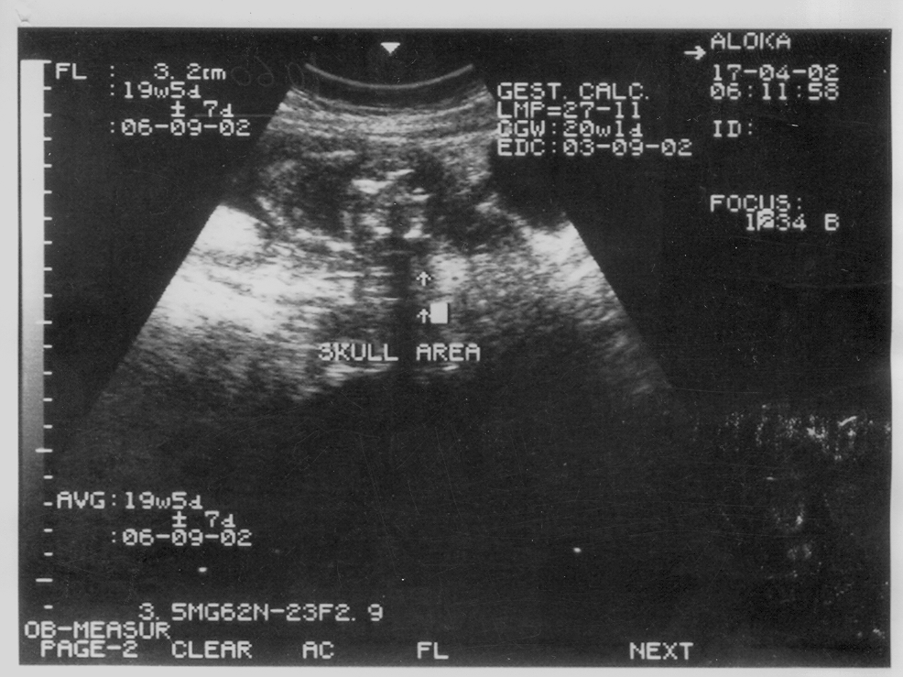

Fig. 4: Anencephaly.
Antenatal ultrasonography is a non–invasive highly sensitive, accurate and cost effective imaging technique which gives good results in experienced hands .Other tests can be used adjunctively.Meticulous screening for pregnant ladies by ultrasound, especially in 2nd trimester and follow up of anomaly cases if required helps a great deal in avoiding un-necessary state expenditure, mental agony and trauma to family of carrying a handicapped child. We need to improve our cardiac imaging of antenatal fetuses in armed forces as we are handicapped due to equipment and lack of expertise in this field due to which there are quite a good number of cardiac cases which go undetected.
REFERENCES
- Smith NC, Smith APM. Detection of congenital fetal anomalies. In: Obstetric Ultrasound made easy. Churchill Livingstone 2002; 42-43.
- Whiteman VE, Reece EA. Prenatal diagnosis of major congenital malformations Curr Opin Obst Gynae 1994; 6: 459-67
- Fleischer AC, Romero R, Frank A. Manning, Philippe Jeanty, A Evertte James, Jr. Prenatal Detection of Anatomic Congenital Anomalies. In: The Principles and Practice of Ultrasonography in Obstetrics and Gynaecology. Prentice-Hall International Inc 1995; 193-7.
- Zaidi S. Diagnosis of Foetal Malformation by Ultrasound In: Real-time ultrasound in obstetric and Gynaecology. Third World Enterprises (Private) Ltd Karachi 1988; 94-120.
- Grandjean H, Larroque D Levi S. The performance of routine ultrasonographic screening of pregnancies in Eurofetus study. Am J Obst Gynae 1999; 181: 446-54.
- Shami SA, Sultan M. Congenital Malformations and Consanguinity. Pak Armed Forces Med J 1997; 47: 70-2
- Hashmi M. Frequency of consanguinity and its effect on congenital malformation - a hospital based study. J Pak Med Assoc 1997; 47: 75-8.
- Long G, Sprig A. A comparative study of routine versus selective fetal anomaly ultrasound scanning. J Med Screen 1998; 5: 6-10.
- Morimoto K, Yoshimine T, Hayakawa T, Antenatal detection of developing nervous system abnormalities and perinatal surgical management (In Japanese). No Shinkei Geka 1989; 17(10): 965-71.
- Lockwood C J, Weiner S. Assessment of fetal growth. Clinical Perinatology 1986; 13: 3-35.
- Romero R, Oyarzun E, Surtori M, Hobbins JC. Detection and management of anatomic congenital anomalies. A new obstetric challenge. Obst and Gynae Clinics of North Am 1988; 15: 215-36.
- Carvalho MH, Brizot ML, Lopes LM, Cluba CH, Muyadohira S, Zigaib M. Detection of fetal structural abnormalities at the 11-14 week ultrasound scan. Prenat Diagn 2002;22:1-4
- Hill LM, Breckle R, Gehrking WC. The prenatal detection of congenital malformations by ultrasonography. Mayo Clin Proc 1983; 58: 805-26.
- Dillon E, Walton SM. The antenatal diagnosis of fetal abnormalities: a 10 year audit of influencing factors. Br J Radiol 1997; 70: 341-6.
- Stoll C, Tenconi R, Clementi M. Detection of congenital anomalies by fetal ultrasonographic examination across Europe. Community Genetics 2001; 4; 225-32.
- Valentin L, Marsal K. Does the prenatal diagnosis of fetal urinary tract anomalies affect perinatal outcome? Ann N Y Acad Sci 1998; 847: 59-73.
- Crane JP, LeFevre ML Winborn RC, A randomized trial of prenatal ultrasonographic screening; impact on the detection, management and outcome of anomalous fetus. The RADIUS study group. Am J Obst Gynae 1994; 171: 392-9.

