TICK BORNE RELAPSING FEVER
Kamran Aziz, *Syed Dilawar Abbas Rizvi, **Muhammad Naqeeb, **Tariq Shakoor
POF Hospital Wah Cantt, *PNS Shifa Karachi, **Combined Military Hospital Gilgit

INTRODUCTION
Borrelial diseases are an important cause of undiagnosed fever. Improved standards of living and better sanitary conditions have almost completely controlled louse borne relapsing fever; however sporadic cases of tick borne relapsing fever are still seen. Its true incidence is more than the reported one [1] and diagnosis can only be established if the condition is kept in mind as is highlighted in our case.
CASE REPORT
A young AFNS officer developed high grade fever, vomiting and generalized body aches while she was availing her leaves in Rawalakot, Azad Kashmir. There were no cough, dysuria, diarrhoea or skin rashes. Apart from symptomatic treatment, she was treated with tablet ofloxacin by a general practioner without any improvement. Seven days after the onset of disease she was admitted to CMH Gilgit with temperature, 1030F and vomiting. Physical examination was unremarkable apart from just palpable spleen and liver. Her blood picture, urinalysis, X ray chest, serum urea electrolytes, liver functions and widal test were not contributory. Blood slides for MP were repeatedly negative. She was empirically treated with a course of tablet chloroquine but fever persisted as such. On third day of her admission, two small erythematous indurated lesions were noted on her arm. She clearly remembered the appearance of the lesions overnight four days prior to the onset of fever; however neither she noticed any insect nor she considered it to be related to her disease. Keeping relapsing fever in mind, blood samples were taken during spike of fever for spirochetes (Borellia) and it was found to be positive (fig). She was accordingly treated with Capsule tetracycline. Her fever settled within two days and then she remained symptom free.
DISCUSSION
Relapsing fever, characterized by recurrent episodes of fever alternating with afebrile phase, includes two distinct clinical entities, tick borne relapsing fever (TBRF) and louse borne relapsing fever (LBRF). It is caused by different Borellia species like Borellia recurrentis and Borrelia duttoni etc [2].
LBRF is transmitted to man by body lice which get infected by feeding on spirochetemic patient. Borellia reaches its hemolymph and multiply there. The disease therefore is neither transmitted by louse bite (anterior station transmission) or by feces (posterior station transmission). It is acquired only if an infected louse is crushed over an abrasion on skin or mucous membrane [3].
TBRF usually occurs sporadically. Soft ticks get infected by feeding on other mammalian hosts like rodents or lagamorphs. Borellia invades its all body tissues including salivary glands & ovaries. Once infected a tick may carry borellia for ten or more years and even transmit it vertically over several generations.. In contrast to lice, ticks transmit disease to human by almost painless bites [4]. Once in the body borellia multiply in blood and after an incubation period of 7 days (2 – 18 days) disease starts with high grade fever, headache, chills, sweats, myalgia and severe arthralgias. Sleep is disturbed by dreams. There is tachypnoea, tachycardia and in about one third of cases petechiae may be seen on trunk, limbs and mucous membranes. Epistaxis and haemoptysis are also frequently seen. Cough is common with occasional pleuritic chest pain and pleural rub. Liver and spleen show mild to moderate enlargement. The severity of disease is related to the number of spirochetes in blood. During remissions borrelia may sequester in liver, spleen, bone-marrow and other tissues. Complications include iridocyclitis, meningitis, cranial nerve palsies, coma, pneumonia, myocarditis, and splenic rupture. Abortion and still birth may occur in infections during pregnancy. Disease may also be transmitted to newborn [3,5].
Correspondence: Surgeon Commander Syed Dilawar Abbas Rizvi, Classified Dermatologist, PNS Shifa Karachi.
Without treatment disease aggravates for 2-7 days and then settles with the disappearance of spirochetes from blood. Fever usually relapses in a week. Such relapses typically occur once or twice in TBRF but may be seen as many as ten times in LBRF. The intensity of symptoms however decreases and interval increases with each relapse [3].
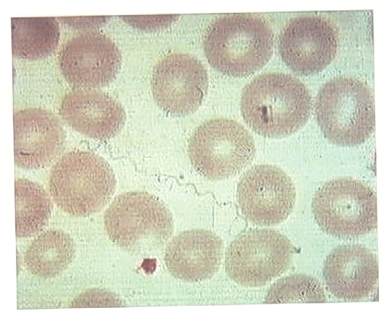
Fig: Peripheral blood film showing borrelia
Diagnosis of borrelia is confirmed by the detection of spirochetes in blood, buffy coat, bone-marrow or CFS. Borrelia may be seen by dark ground illumination or in blood smears stained by Wright’s or Giemsa stain. Blood smears are positive in 70% of LBRF and in fewer cases of TBAF. It may also be cultured from blood on BSK medium or intraperitoneal inoculation of immature mice. Weil Felix reaction with OXK supports diagnosis in convalescent phase [3,6].
Borreliae are sensitive to penicillin, erythromycin, tetracycline and chloramphenicol. LBRF is usually treated with a single dose of antibiotics. TBRF on the other hand is empirically treated for seven days. Jarish Hexhiemer reaction is usually seen with in 1-4 hours and its severity may be decreased to some extent by glucocorticoids and NSAIDS. Mortality rate of untreated LBRF is high but in treated patients it is less than 5%. TBRF on the other hand is a milder disease with lower case fatality rate [3,5].
Prevention of LBRF is generally directed at the control of lice infestation. TBRF can be prevented by avoiding rodents and tick infested places and wearing protective clothing [7]. All cases of relapsing fever should therefore be reported to public health authorities for prompt initiation of preventive measures.
REFERENCES
- Mc Connell J. Tick-borne relapsing fever under-reported. Lancet Infect Dis 2003; 3(10): 604.
- Kisinza WN, Mc Call PJ, Mitani H, et al. A newly identified tick borne Borrelia species and relapsing fever in Tanzania. Lancet 2003; 362 (9392): 1283-4.
- David T Dennis, Grant L Campbell. Relapsing fever. In: Fauci, Braunwald, Isselbacher, et al, eds. Harrison’s Principles of Internal Medicine, Mc Graw Hill 1998; 2: 1038-1041.
- McGinley- Smith DE, Tsao SS. Dermatoses from ticks. J Am Acad Dermatol 2003; 49(3): 363 – 92.
- Newton J A, Papper PV, Images in clinical medicine. Relapsing fever. N Engl J Med 1996; 335 (16): 1197.
- Chatel G, Gulletta M, Matteelli A, et al. Short report: Diagnosis of tick borne relapsing fever by the quantitative buffy coat fluorescence method. Am J Trop Med Hyg 1999; 60(5): 738-9.
- Dworkin MS, Shoemaker PC, Fritz CL, et al. The epidemiology of tick borne relapsing fever in the United States. Am J Trop Med Hyg 2002; 66 (6): 753-8.

